Gulp Roast Copy Assets

# Home Page

There's *nothing* quite like enjoying that perfect cup of coffee.

Our coffee brightens your days—one sip at a time.

Join us at our cafe, or order our beans online. Either way, you're bound to improve your day!

View our coffee *(links to products page)*

# About Us

Life without coffee is a gloomy place. That’s why Gulp Roast has been proudly serving up fresh coffee to the San Francisco area *(link to https://goo.gl/maps/3rAyszfwSDx8Si2Y9)* since 2000. Our coffee is locally sourced with the most delicious blends coming directly to your home, right from coffee farmers near you. Our coffee makes even the most difficult days just a tad easier to get through.

For us, this isn’t just brewing coffee. This is an active life mission to bring our customers the most flavorful, full-bodied beverages we can get our hands on. Browse our site to learn more about our locations and sourcing techniques.

Contact Us *(links to contact page)*

# Our Products

## Columbian-Blended Espresso Beans

With our Columbian-Blended Espresso Beans, you can finally feel like a professional barista. Bright and clean with an intense burst of flavor, these full-bodied beans strike a perfect balance between the most delicate roasts and fruitful aromas.

## Triple-Blended Coffee Beans

Skillfully roasted and carefully blended, our Triple-Blended Coffee Beans don’t just wake you up in the morning, they pack a lasting punch that's sure to leave you wanting more. With silky smoothness and layered flavors, there’s really no better way to start your day.

## Lightly Roasted Coffee Beans

Our Lightly Roasted Coffee Beans offer the world a chance to brighten every day with a whole lot of flavor and inspiration. Try these to receive the perfect balance between bold flavor and subtle sweetness.

# Contact Us

200 Fisherman's Dock

San Francisco, CA 94158

123-456-7890

(BONUS: Can you figure out how to make the phone number clickable on a mobile device? Check MDN for how to link phone numbers and see if you can figure it out.)

# Disclaimer in footer

© 2022 Trilogy Education Services, a 2U, Inc. brand. All Rights Reserved.

This site is operated by Trilogy Education Services for educational purposes only. This is not a restaurant website. This is a fictitious company and scenario intended only for internal academic purposes.

Facebook: link to <https://www.facebook.com>

Twitter: link to <https://www.twitter.com>

Instagram: link to <https://www.instagram.com>

Style Guide

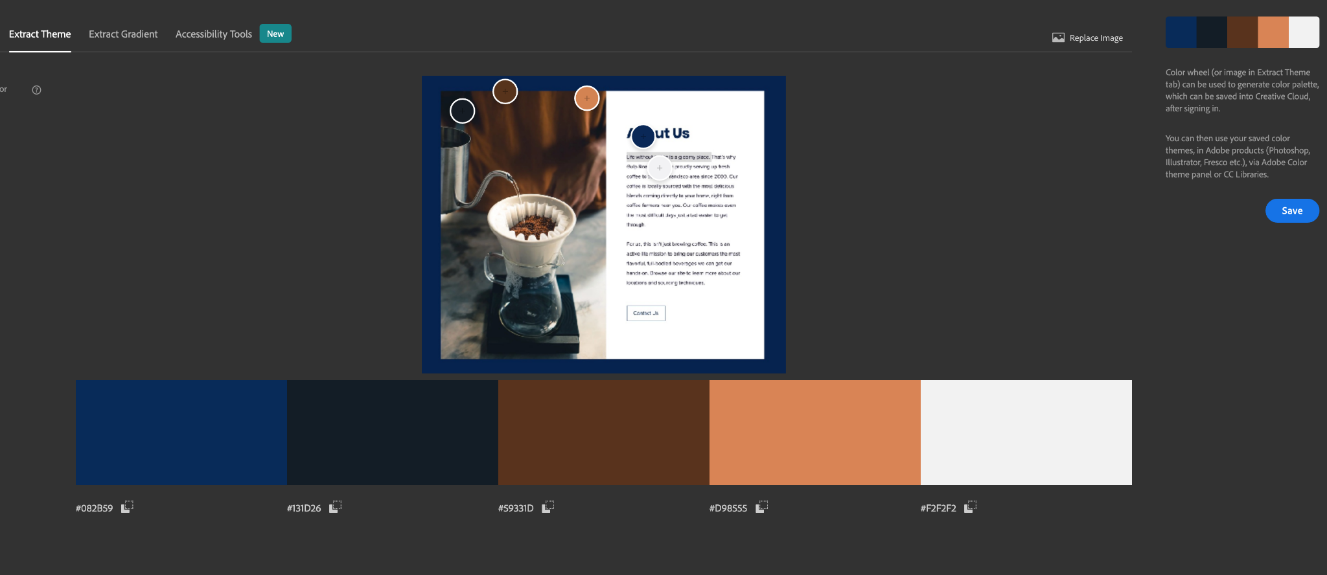

## Colors:

Bright blue: #082B59

Navy: #131D26

Coffee: #59331d

Peach: #D98555

White: #f2f2f2

## Fonts:

Headings: Poppins 700

All other text: Lato 400

## High-Fidelity Prototypes

[Gulp Roast High-Fidelity Prototypes - Figma](https://www.figma.com/proto/QQdH6cOvwVHd2kO4A61NWt/M18-Challenge-Gulp-Prototypes?scaling=min-zoom&page-id=0%3A1&starting-point-node-id=11%3A134&show-proto-sidebar=1&node-id=11%3A134)